Teaching Untaught Histories

FREE Workshop

The Untold Story of the Department of Justice Incarceration of People of Japanese Ancestry
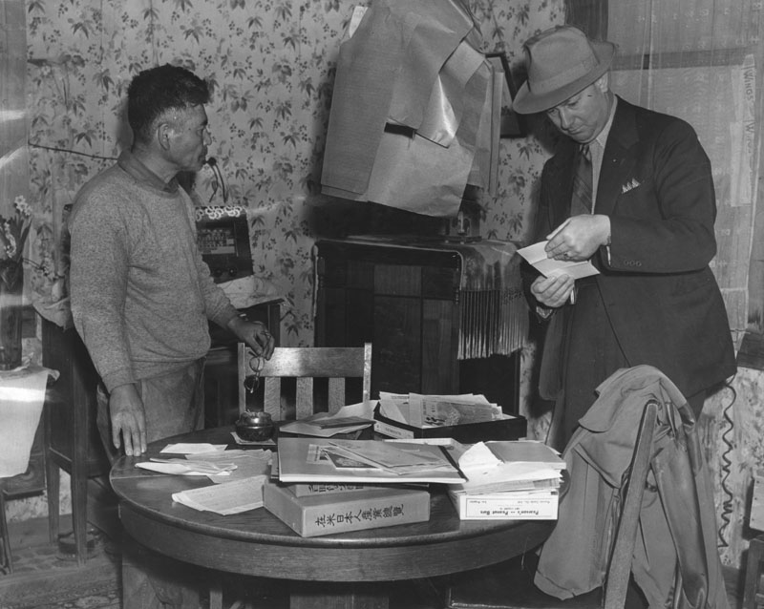

April 28, 2018
8:30 AM - 5:00 PM

Japanese American Service Committee
4427 N Clark St, Chicago, IL 60640

Workshop for Middle and Secondary
Social Studies and Humanities Educators

Award of $150 Stipend
Refreshments and
light lunch provided

Standards
Based Resource Packet

P.D. Credit available

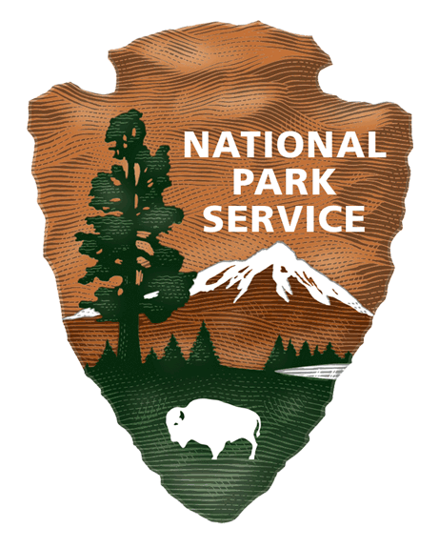

In the 1930s and 1940s numerous people living in the United States were identified as “enemy aliens” and placed on a secret government list called the Custodial Detention List. Join your colleagues for open-ended inquiry to consider the question - How did being placed on the government’s Custodial Detention List impact the lives and communities of people of Japanese ancestry?

We take a close look at the Custodial Detention List and the political policies and climate that led to the incarceration of both citizens and aliens of Japanese ancestry within hours of the bombing of Pearl Harbor. Through dialogue, primary materials, personal stories, we piece together a more complex narrative and analysis about the earliest government actions, public response, and the trauma, resilience, and resistance of the individuals and communities of people of Japanese ancestry.

The workshop is co-sponsored by the National Japanese American
Historical Society, San Francisco; the National Park Service; the
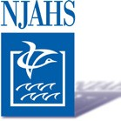
Japanese American Service Committee, Chicago; the Chicago
Japanese American Historical Society; and the Delta Kappa Gamma
Society International-Beta Psi Chapter. The NPS Japanese Confinement Sites
Grant Program funds this workshop.

The mission of the Japanese American Historical Society in San Francisco, CA is to
educate the public about the contributions of Japanese Americans to American
society. For more information see njahs.org.

OUR WORKSHOP TEAM

Melissa Ayumi Bailey is the Program Development Associate for the National Japanese American Historical Society (NJAHS) where she has been on staff since 2013. She is primarily responsible for grant writing and project management. Melissa received her BA in History from UC Santa Cruz in 2012, and her experiences there as well as her personal connection to the Japanese American incarceration experience led her to pursue a position at NJAHS. Melissa is a native San Franciscan and still calls "The City" home to this day. Outside of work, she serves as the Editor for the San Francisco Nisei Fishing Club, an organization her family has been a part of for three generations. melissa@njahs.org

Lynn Fonfa brings over thirty five years of experience in the field of education. She joined the National Park Service in 1989, and has been the Education Specialist for the Golden Gate National Recreation Area since 1995, directing the K through 12 programs for one of the largest urban national parks. She earned a Master’s Degree in Education, with a specialty in Environmental Education/Curriculum Design, and a Master’s Degree in Public History, specializing in United States history and historic preservation. Previous to the NPS, Lynn worked as an archivist, educator, and development associate with several prestigious historic associations, including the California Historical Society and the Western Jewish Historical Center of the Judah L. Magnes Museum in Berkeley. lynn_fonfa@nps.gov

JEAN MISHIMA is the President of the Chicago Japanese American Historical Society. Since the mid-1990's, CJAHS has presented a first-voice narrative on the incarceration of Japanese and Japanese Americans during WW II. And as a Special Education teacher for 12 years with the Chicago Public School System, and a Special Needs Counselor at Lincoln Park High School for 9 years, Mishima gained the experiences as an educator to spearhead an educational subcommittee in developing a multicultural curriculum for grades K-12. She has co-presented numerous teachers’ workshops at the Field Museum and Harold Washington Library. jmmishima@hotmail.com

GRACE MORIZAWA is the Education Coordinator for the National Japanese American Historical Society. Previously she was an elementary school teacher in Oakland and principal of Lake Elementary School in San Pablo, CA. Morizawa is a Sansei, third generation Japanese American. She is a teacher consultant with the Bay Area Writing Project. She has a BA in English from Pacific University, an MA in Creative Writing from San Francisco State, and a doctorate from the Leadership in Education and Equity Program at UC Berkeley. grace@njahs.org

STAN PESICK taught 11th grade United States History in the Oakland Unified School District for eighteen years. Between 2008-2012 he coordinated the Oakland Unified History/Social Studies Department. He has worked with the Bay Area Writing Project as a teacher consultant since 1989. Since 2014 he’s worked as a curriculum consultant to the National Japanese American Historical Society. He is currently working with National Writing Project, UC Berkeley, to develop materials and methods focused on helping students write more effectively for political and civic purposes. Stan has a Ph.D. from Stanford University.

Ryan Masaaki Yokota is the Development and Legacy Center Director at the Japanese American Service
Committee in Chicago, IL, and is also an instructor at DePaul University. He received his Ph.D. in East Asian History at the University of Chicago, and his M.A. in Asian American Studies at UCLA. His academic publications related to this project include a book chapter on Okinawan Peruvians in Los Angeles, and a journal article on Japanese and Okinawans in Cuba. ryokota@jasc-chicago.org

HOW TO APPLY

REFUNDABLE FEE
Applications for Untold Story will be accepted through April 22, 2018, or until our workshop capacity is reached. If you find you are unable to participate in the workshop, please cancel by April 25, 2018 so we can offer your space to another teachers.

You may email your complete application to:
Grace Morizawa
grace@njahs. org
or mail with completed application form (below) to:
Melissa Bailey
April Workshop
National Japanese American Historical Society
1684 Post St.
San Francisco, CA 94115

For information email: grace@njahs.org

Chicago workshop

NAME ADDRESS
CITY, STATE, ZIP

EMAIL BEST PHONE TO REACH
SCHOOL SUBJECT TAUGH

WHY I WANT TO
ATTEND AND HOW I WILL USE THIS IN MY CLASSROOM.
Please check if your are interested in professional development credit.

